Binary Adaptive Paging:
Power-of-Two Region Decomposition with XOR-Based Address Lookup

Student: Abdulmajid alawad
Course: Operating Systems / Memory Management
Instructor: [Instructor Name]
Date: [Submission Date]

Abstract
Fixed-size paging provides a simple and reliable foundation for virtual memory, but it may require many translation entries for large memory regions and can limit effective TLB reach. Huge pages and superpages reduce translation overhead by mapping larger memory ranges, but they introduce practical difficulties related to alignment, fragmentation, protection boundaries, copy-on-write behavior, and sparse access. This paper proposes Binary Adaptive Paging (BAP), an exploratory region-based virtual memory mapping scheme that decomposes each memory region into descending power-of-two chunks. The central idea is that, for an address offset a inside a region of size S, the containing logical chunk can be identified using the most significant set bit of a XOR S. This creates a compact lookup rule for binary-decomposed regions while preserving compatibility with base-page units.
The paper establishes the BAP logical region model and the XOR/MSB chunk-identification rule, then evaluates structural chunk counts, synthetic workload effects, and sensitivity to chunk-size and split thresholds. Under equal maximum logical chunk sizes, BAP limited matches the idealized multi-size baseline for aligned starts. Earlier alignment experiments suggested fewer region-relative chunks for unaligned starts, but these logical counts are not equivalent to hardware-native translation entries. A supplementary v5 virtual-alignment audit evaluates two explicit page-size profiles: a hypothetical profile supporting every power-of-two size through 512 base pages and a 4 KiB/2 MiB x86 leaf-page profile. For a 10,000-page region starting at virtual page 1, the 21 original BAP limited chunks are not directly eligible native leaves in either profile. Aligned retiling requires 30 leaves in the hypothetical profile and 802 in the 4 KiB/2 MiB profile. These are structural, virtual-alignment counts, not measurements of physical feasibility, TLB misses, or runtime performance. BAP therefore remains a logical organization and address-lookup proposal whose practical translation path must be specified and evaluated before claiming hardware-level benefits.
Keywords: virtual memory, binary region decomposition, XOR/MSB lookup, virtual alignment, translation feasibility, large pages, simulation

Contents
- 1. Introduction
- 2. Background and Motivation
- 3. Binary Adaptive Paging Design
- 4. Formal Model and Lookup Rule
- 5. Correctness Argument
- 6. Simulation Methodology
- 7. Results
- 8. Discussion
- 9. Limitations and Threats to Validity
- 10. Related Work
- 11. Conclusion
- References
- Appendix A. Reproducibility Notes

1. Introduction
Virtual memory is one of the central abstractions in modern operating systems. It allows each process to observe a private address space while the operating system and hardware cooperate to translate virtual addresses into physical locations. The most common practical design is page-based translation with a fixed base page size, such as 4 KB. Fixed-size paging is simple, well supported by hardware, and convenient for protection and demand paging. However, it also means that a large region may require a large number of page-table entries and many small translations in the translation lookaside buffer (TLB).
Large pages, huge pages, and superpages address this problem by allowing one translation entry to cover a larger memory range. This increases TLB coverage and can reduce page-table overhead. However, large pages are not a free solution. They often require suitable alignment and physical contiguity, can amplify page faults when access is sparse, and may interact badly with protection boundaries or copy-on-write. Transparent huge-page mechanisms attempt to make this process automatic, but they still need promotion, demotion, and split policies.
This paper explores a different point in the design space. Binary Adaptive Paging (BAP) organizes each virtual memory region into descending power-of-two logical chunks. A region of 13 base pages is represented as 8 + 4 + 1 pages, and for an address offset a in a region of size S the containing logical chunk is identified by MSB(a XOR S). Variable-size mappings already exist: BAP's candidate contribution is a compact region-relative representation and lookup rule, not the invention of large pages. In particular, a logical BAP chunk is not automatically a hardware-supported page mapping or one TLB entry.
This work formulates the logical scheme, provides a correctness argument for its lookup rule, and uses exploratory simulations to evaluate mapping-count tradeoffs, synthetic whole-chunk activation, permission-boundary refinement, and parameter sensitivity. A separate v5 audit tests the virtual-alignment and native-page-size eligibility of BAP's proposed chunks. No operating-system implementation or physical-memory translation mechanism is claimed.

Contributions
- A region-relative logical chunk representation based on descending power-of-two decomposition.
- A compact XOR/MSB lookup rule for identifying the logical chunk containing an address inside a binary-decomposed region.
- A comparison of logical chunk counts for fixed, huge-page-style, idealized multi-size, aligned multi-size, and limited/unbounded BAP models under stated assumptions.
- A workload-aware synthetic model of whole-chunk activation, split pressure, and permission-boundary refinement (not measured OS page faults).
- A parameter sensitivity study and a v5 audit of virtual alignment and native leaf-page eligibility that identify conditions under which logical BAP chunks cannot be treated as conventional hardware translations.

2. Background and Motivation

2.1 Fixed-size paging
In fixed-size paging, a process address space is divided into equal-size virtual pages, and physical memory is divided into equal-size frames. For a base page size of 4 KB, the lower 12 address bits are the offset inside the page, and the remaining bits identify the virtual page number. This structure makes translation simple, but a large region requires one mapping entry per base page.
page_number = address >> 12
offset = address & 0xFFF

2.2 Huge pages and superpages
Huge pages and superpages reduce the number of translations by allowing larger mappings. Prior work on superpages notes that one TLB entry can map a large physical memory region into a virtual address space, which increases TLB coverage and may reduce TLB misses [1]. Linux HugeTLB and Transparent Huge Pages are practical examples of large-page mechanisms. Linux documentation describes Transparent Huge Pages as a mechanism for automatically using huge pages as backing for virtual memory, including promotion and demotion of page sizes [2]. Linux HugeTLB documentation also highlights the importance of physically contiguous huge-page allocation, especially when huge pages are allocated early in boot [3].
Large pages can reduce translation-entry counts, but their feasibility is constrained by supported page sizes, alignment, backing, and protection requirements. Whether touching part of a larger range triggers whole-range allocation or loading is operating-system and policy dependent. Accordingly, the synthetic 'fault amplification' measure later in this paper is a modeled whole-chunk-activation ratio, not a universal prediction of hardware page faults.

2.3 Multi-size mappings and region-based designs
Modern processors and operating systems often support multiple page sizes. For example, x86-64 systems commonly support 4 KB, 2 MB, and 1 GB pages, and recent research such as Trident studies how to exploit all page sizes dynamically in Linux [5]. Region-based designs, including Direct Segments, also reduce translation overhead by mapping large contiguous regions using base, limit, and offset-style hardware support [4]. BAP is related to these ideas, but it is region-relative and binary-decomposed. It studies whether a compact bit-level lookup rule can organize variable-size chunks without treating the whole process as one fixed segment.

3. Binary Adaptive Paging Design

3.1 Design overview
Binary Adaptive Paging operates at the level of virtual memory regions rather than whole processes. A process normally contains several regions, such as code, read-only data, heap, mapped files, shared libraries, stack, and guard pages. These regions may have different permissions and backing policies, so the scheme decomposes each region independently. The smallest unit is still the normal base page; all sizes in this paper are measured in base-page units.
For a region of size S, the scheme represents S as a sum of descending powers of two. For example:
S = 13 = 8 + 4 + 1
S = 19 = 16 + 2 + 1
S = 10000 = 8192 + 1024 + 512 + 256 + 16

The chunks are laid out in descending order from the beginning of the region. For S = 13, the layout is [0,8), [8,12), and [12,13). Each chunk has a size that is a power of two, and the number of chunks is equal to the number of set bits in S if the unbounded scheme is used.

3.2 Limited and unbounded variants
The evaluation distinguishes two logical BAP variants. Unbounded BAP represents the region using the set-bit decomposition of S without an imposed maximum. Limited BAP divides any larger logical chunk into subchunks capped at 512 base pages in the main experiments. Although 512 base pages equals 2 MiB for a 4 KiB base page, these are logical region-relative chunks: the cap by itself does not establish native hardware support, virtual/physical alignment, or contiguity. The cap makes logical-size comparisons meaningful; hardware realizability is examined separately in Section 7.3.1.
Table 1. BAP variants used in the paper.
Variant | Meaning | Use in evaluation
binary_adaptive_limited | Caps region-relative logical chunks, e.g., at 512 base pages; not automatically native leaves | Size-capped logical comparison; virtual-alignment eligibility audited in v5
binary_adaptive_unbounded | Allows logical chunks larger than the common 512-base-page comparison cap | Theoretical upper bound

3.3 Adaptive split and merge motivation
A large logical chunk may be economical for a densely accessed uniform region, but a practical mapping design must handle sparse access, copy-on-write, permission boundaries, and updates. The v3 simulator approximates a policy that loads or activates an entire touched chunk and then counts segments produced by a simplified split rule. These figures describe pressure under that policy assumption; they are not measurements of real kernel splitting or hardware page-fault behavior.

4. Formal Model and Lookup Rule

4.1 Region model
A virtual memory region R is represented by a base address B, a size S measured in base pages, and attributes such as permissions and backing type. For a virtual address A inside the region, the normalized address offset is a = A - B. All formulas below use normalized offsets in base-page units.
R = (B, S, permissions, backing)
0 <= a < S
a = A - B

4.2 Binary decomposition
Let S be a positive integer. Its binary representation defines a descending list of powers of two. If bit k is set in S, then the decomposition contains a chunk of size 2^k. Chunks are ordered from larger powers to smaller powers.
decompose(S):
chunks = []
for k from floor(log2(S)) down to 0:
if bit k of S is set:
chunks.append(2^k)
return chunks

4.3 XOR/MSB lookup rule
For an address offset a inside a region of size S, BAP computes x = a XOR S and then k = MSB(x), where MSB returns the index of the most significant set bit. The logical chunk size is then 2^k. The chunk base is obtained by clearing the lower k+1 bits of S:
x = a XOR S
k = MSB_position(x)
chunk_size = 1 << k
chunk_base = S & ~((1 << (k + 1)) - 1)

For example, when S = 13 = 1101b, the decomposition is 8 + 4 + 1. For a = 9, x = 9 XOR 13 = 4, so k = 2 and the address belongs to the 4-page chunk. For a = 12, x = 12 XOR 13 = 1, so k = 0 and the address belongs to the 1-page chunk.

4.4 Translation algorithm
locate_logical_chunk(A, region, max_chunk):
B, S = region.base, region.size # all quantities in base-page units
if A < B or A >= B + S: raise RegionMiss
a = A - B
k = MSB_position(a XOR S)
logical_base = S & ~((1 << (k + 1)) - 1)
logical_size = 1 << k
if logical_size <= max_chunk:
chunk_base, chunk_size = logical_base, logical_size
else:
sub_index = (a - logical_base) // max_chunk
chunk_base = logical_base + sub_index * max_chunk
chunk_size = max_chunk
return (chunk_base, chunk_size, a - chunk_base)
# This identifies a LOGICAL chunk only.
# Physical frame lookup, eligibility, permissions and TLB fill are unspecified.

The algorithm above locates a logical chunk and an intra-chunk offset; it is not a complete virtual-to-physical translation algorithm. Such a translation additionally needs a region-discovery mechanism, a mapping from each eligible chunk or base page to physical backing, appropriate permissions, and a defined TLB/page-walker interface. Section 7.3.1 tests the necessary virtual prerequisites under selected page-size profiles, while physical prerequisites remain open.

5. Correctness Argument
The central correctness property is that MSB(a XOR S) identifies the power-of-two chunk containing a when the region is decomposed into descending powers of two. The proof is based on the fact that the descending binary chunks correspond to intervals formed by clearing suffixes of S.

Theorem
Let S be a positive integer and let 0 <= a < S. Suppose S is decomposed into descending powers of two according to its set bits, and the resulting chunks are laid out from lower to higher offsets. Let k = MSB(a XOR S). Then a lies in the chunk of size 2^k whose base is S with all bits below and including k cleared.

Proof sketch
Because a < S, the binary strings of a and S must differ at some most significant bit. Let k be the highest bit at which they differ. Since S is larger than a, S has bit k equal to 1 and a has bit k equal to 0 after the common higher prefix. Bits above k are equal in both numbers. Therefore, clearing the lower k+1 bits of S gives the start of the interval whose length is 2^k. The address a shares the higher prefix, has 0 at bit k, and can vary in lower bits, so it falls inside that interval. This interval is exactly the chunk corresponding to bit k in the descending binary decomposition. Since XOR marks exactly the bit positions where a and S differ, MSB(a XOR S) returns this same k.
The simulator also validates this rule exhaustively for all region sizes up to the configured maximum by comparing the XOR/MSB lookup with a naive boundary scan. This validation is not a formal proof by itself, but it is useful as an implementation sanity check.

6. Simulation Methodology

6.1 Goals
The evaluation consists of two distinct types of evidence. Simulators v2–v4 estimate logical region chunk counts, an optimistic TLB-reach proxy based on choosing the largest chunks, and synthetic whole-chunk activation and splitting behavior. Simulator v5 checks virtual alignment and native page-size eligibility of the same logical chunks for two explicit hypothetical/conventional leaf-size profiles. Neither class of experiment measures real TLB hit rates, page-walk latency, physical contiguity, or end-to-end program performance.

6.2 Baselines
Table 2. Mapping strategies evaluated by the simulator.
Strategy | Description | Purpose
fixed | One mapping per base page | Standard page-based baseline
huge_mixed | 512-page mappings plus base-page remainder | Simple huge-page-style baseline
multi_size_unaligned | Greedy use of multiple sizes without alignment constraints | Strong idealized baseline
multi_size_aligned | Greedy multi-size mapping with virtual alignment constraints | More realistic multi-size baseline
binary_adaptive_limited | BAP with maximum chunk cap | Fair BAP comparison
binary_adaptive_unbounded | BAP without maximum chunk cap | Theoretical upper bound

6.3 Metrics
Table 3. Main simulation metrics.
Metric | Meaning
logical_mapping_count | Number of region-relative logical chunks (not necessarily hardware leaf entries)
estimated_tlb_reach_pages | Optimistic largest-chunk coverage proxy; not simulated TLB hit rate
alignment_penalty_entries | Difference in logical counts when absolute virtual alignment is imposed
fault_amplification | Modeled loaded/touched ratio under whole-chunk-activation assumption
adaptive_split_added_entries | Extra entries introduced by adaptive split
permission_refined_mapping_count | Mapping count after splitting at permission boundaries

6.4 Workloads
Table 4. Synthetic workloads in Simulator v3.
Workload | Description
dense_sequential | Every page in the region is touched
sparse_random | About 2% of pages are touched randomly
very_sparse_random | About 0.2% of pages are touched randomly
hot_cold_clustered | One hot cluster plus a small number of cold random touches
boundary_sparse | Pages near chunk boundaries are touched
cow_burst | A small contiguous write burst approximates COW pressure
mixed_permissions | Synthetic permission boundaries force mapping refinement

6.5 Experimental settings
Unless stated otherwise, one base page is the simulation unit and the principal cap is 512 base pages. The v2–v4 experiments use a 64-slot optimistic largest-chunk coverage proxy (not a TLB simulator); structural region sizes include 1–10,000 pages, and workload-aware runs focus on 1,000, 4,096, and 10,000 pages. Sensitivity runs vary BAP's cap among 128, 256, 512, 1,024, and 2,048 pages and the density threshold among 0.05, 0.10, 0.25, and 0.50, over five seeds. In v5, the cap is 512 pages, region sizes are 13, 19, 513, 1,000, 4,096, and 10,000, and starts are 0, 1, 7, 13, 64, and 255, for two leaf-size profiles (72 cases). v5 tests only virtual alignment and page-size membership, not physical backing or actual TLB behavior.

7. Results

7.1 Structural mapping-count results
The original structural experiment compares logical chunk counts when regions start at page 0. The BAP limited and idealized multi-size strategies share the same maximum logical block size. This controls the logical decomposition comparison, but does not establish equivalent native page-table support or TLB representation.
Table 5. Fair structural comparison for aligned region start.
Region size | Fixed | Huge mixed | Multi-size unaligned | Multi-size aligned | BAP limited | BAP reduction vs fixed (%)
13 | 13 | 13 | 3 | 3 | 3 | 76.92
19 | 19 | 19 | 3 | 3 | 3 | 84.21
512 | 512 | 1 | 1 | 1 | 1 | 99.80
513 | 513 | 2 | 2 | 2 | 2 | 99.61
1000 | 1000 | 489 | 6 | 6 | 6 | 99.40
4096 | 4096 | 8 | 8 | 8 | 8 | 99.80
10000 | 10000 | 291 | 21 | 21 | 21 | 99.79
Note. Counts are logical chunk counts; a 512-page cap alone does not imply that every resulting block is a native 2 MiB translation.

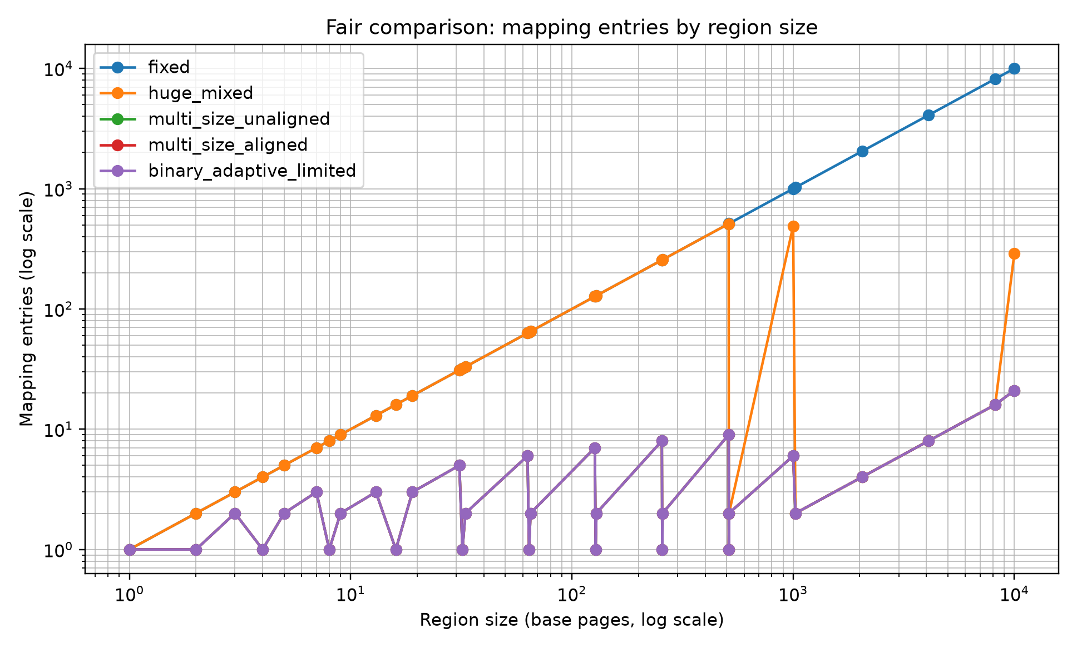
Figure 1. Fair comparison: mapping entries by region size.

In the logical decomposition model, a 10,000-page region uses 10,000 fixed-size chunks or 21 BAP limited chunks. For aligned starts and the same maximum chunk size, BAP limited matches the strong idealized multi-size models rather than improving their count. These counts should not be interpreted as actual page-table entries or hardware TLB entries without an implementation model and page-size/alignment eligibility checks.

7.2 Upper-bound behavior
Table 6. Upper-bound comparison with unbounded BAP.
Region size | Fixed | Huge mixed | BAP limited | BAP unbounded | Unbounded reduction vs fixed (%)
13 | 13 | 13 | 3 | 3 | 76.92
19 | 19 | 19 | 3 | 3 | 84.21
512 | 512 | 1 | 1 | 1 | 99.80
513 | 513 | 2 | 2 | 2 | 99.61
1000 | 1000 | 489 | 6 | 6 | 99.40
4096 | 4096 | 8 | 8 | 1 | 99.98
10000 | 10000 | 291 | 21 | 5 | 99.95
Note. Unbounded BAP is a logical decomposition upper bound, not a claim of support for an arbitrary hardware page size.

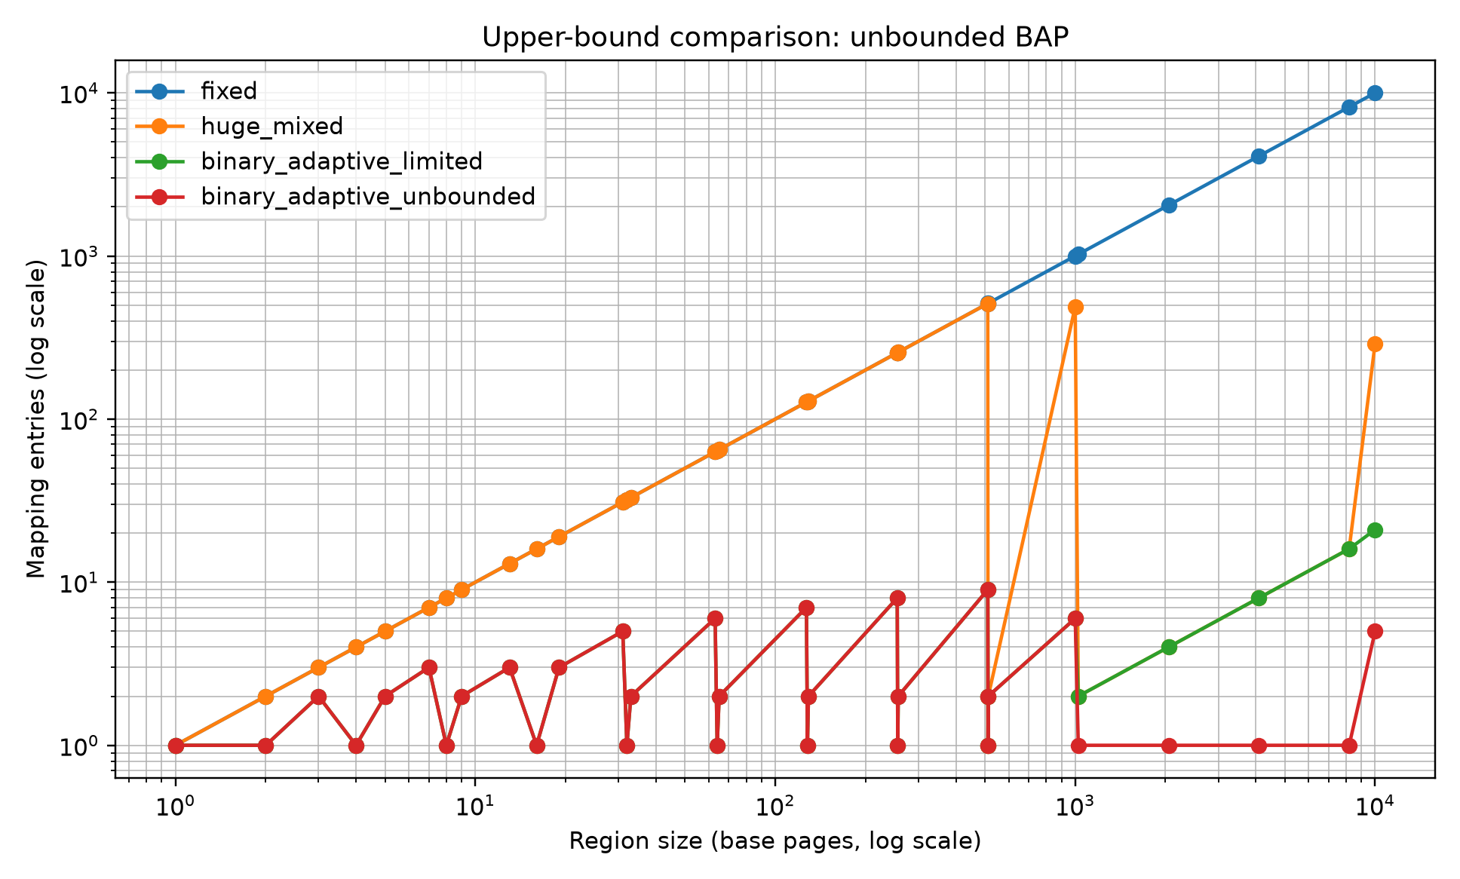
Figure 2. Upper-bound comparison: unbounded BAP.

Unbounded BAP decomposes 4,096 pages into one logical chunk and 10,000 pages into five logical chunks (8,192 + 1,024 + 512 + 256 + 16). This is an upper bound on logical representation size only; it does not assume existing hardware can implement each chunk as an independent translation leaf.

7.3 Alignment sensitivity
Table 7. Logical chunk counts under region-start offsets (abstract v2 model).
Region start | Multi-size unaligned | Multi-size aligned | BAP limited | BAP unbounded | Alignment penalty
0 | 21 | 21 | 21 | 5 | 0
1 | 21 | 30 | 21 | 5 | 9
7 | 21 | 30 | 21 | 5 | 9
13 | 21 | 30 | 21 | 5 | 9
64 | 21 | 24 | 21 | 5 | 3
255 | 21 | 25 | 21 | 5 | 4
Note. BAP chunks are relative to the region base and are NOT necessarily legal native hardware page mappings. Section 7.3.1 audits the prerequisite alignment and size support.

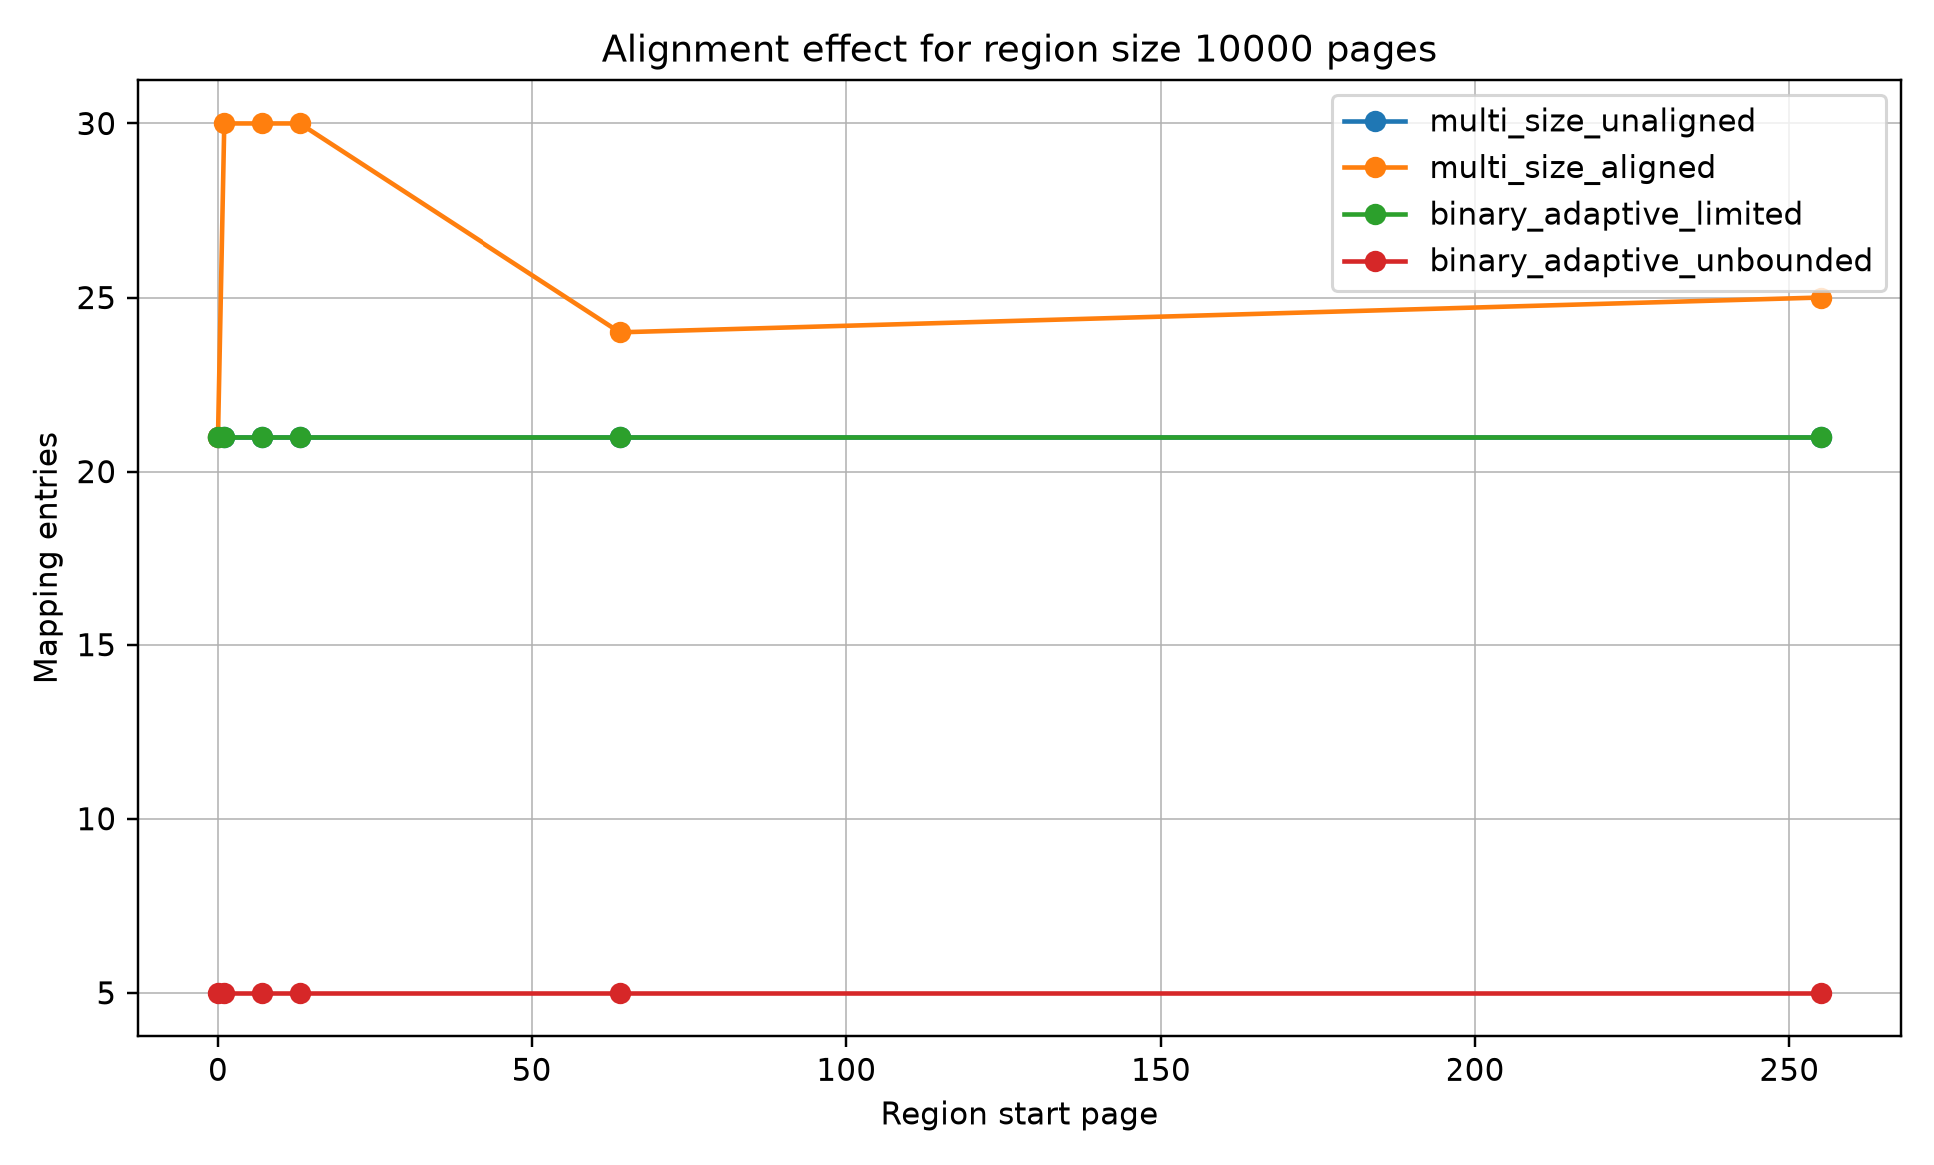
Figure 3. Logical region-relative chunk counts versus aligned multi-size counts (not TLB results).

The original v2 model counts 21 BAP limited logical chunks for a 10,000-page region regardless of whether the region starts at page 0, 1, 7, or 13; the alignment-constrained multi-size model counts 21 for start 0 and 30 for starts 1, 7, or 13. This demonstrates an assumption of the region-relative representation, not 21 immediately realizable hardware translation leaves. A native large-page entry requires an allowed size and virtual alignment, with further physical and protection constraints. The feasibility check below tests these necessary virtual conditions rather than assuming them away.

7.3.1 Virtual-alignment and page-size feasibility (v5)
The v5 structural audit examines whether each original BAP limited block has an allowed native leaf size and begins at an absolutely aligned virtual address. It reports (i) original logical blocks, (ii) blocks individually eligible for a native leaf, (iii) legal aligned leaves obtained by splitting within original BAP block boundaries, and (iv) leaves obtained by realigning/retiling the entire region. Two explicit profiles are considered: 'ideal powers of two' (every native size 1, 2, 4, ..., 512 base pages, hypothetical) and 'x86 4 KiB/2 MiB' (native leaf sizes 1 and 512 base pages only; 1 GiB leaves are excluded by this 512-page cap). All counts assume adequate physical backing and do not model TLB operation.
Table 7a. Virtual eligibility and aligned retiling, S = 10,000 base pages (v5).
Profile | Start page | BAP logical chunks | Directly eligible chunks | Split only: legal leaves | Retile: aligned leaves
Ideal powers of two | 0 | 21 | 21 | 21 | 21
Ideal powers of two | 1 | 21 | 0 | 204 | 30
Ideal powers of two | 64 | 21 | 1 | 80 | 24
x86 4 KiB/2 MiB | 0 | 21 | 19 | 291 | 291
x86 4 KiB/2 MiB | 1 | 21 | 0 | 10000 | 802
x86 4 KiB/2 MiB | 64 | 21 | 0 | 10000 | 802
Note. Direct eligibility tests only allowed size and virtual alignment, not physical feasibility. Split-only keeps BAP boundaries and is not optimized. Retiling may change them. The all-powers-of-two profile is hypothetical.
Interpretation. The apparent 21-versus-30 advantage in Table 7 is a logical representation comparison, not a native hardware paging advantage. Under the hypothetical all-powers-of-two profile, legal retiling at start page 1 needs the same 30 aligned leaves as the aligned multi-size baseline. Under the limited x86 4 KiB/2 MiB profile, it needs 802 legal leaves; the original 21 BAP chunks cannot serve as native page-table leaves. These findings do not rule out a newly designed region-relative translation mechanism, but such a mechanism must specify its region lookup, physical mapping, metadata costs, protection semantics, and TLB interface. No end-to-end speedup is implied.

7.4 Workload-aware fault amplification
The workload-aware v3 simulation models a deliberate whole-chunk-activation rule: if a chunk is touched, all base pages in that chunk are counted as loaded until a split rule is applied. The ratio (modeled loaded pages)/(unique touched pages) is labeled 'fault amplification' in the original plots. It is not a measured OS page-fault rate, nor a necessary consequence of an abstract translation chunk. In this synthetic model, dense access gives a ratio of 1.0.
Table 8. Selected workload-aware stress results for a 10,000-page region.
Strategy | Workload | Mappings | Touched | Loaded no split | Amplification no split | Adaptive mappings | Loaded after split | Amplification after split
fixed | sparse_random | 10000 | 200 | 200 | 1 | 10000 | 200 | 1
binary_adaptive_limited | sparse_random | 21 | 200 | 9984 | 49.92 | 416 | 200 | 1
binary_adaptive_unbounded | sparse_random | 5 | 200 | 9984 | 49.92 | 402 | 200 | 1
binary_adaptive_limited | hot_cold_clustered | 21 | 550 | 9216 | 16.76 | 113 | 1070 | 1.95
binary_adaptive_unbounded | hot_cold_clustered | 5 | 550 | 9728 | 17.69 | 606 | 550 | 1
fixed | cow_burst | 10000 | 100 | 100 | 1 | 10000 | 100 | 1
binary_adaptive_limited | cow_burst | 21 | 100 | 512 | 5.12 | 122 | 100 | 1
binary_adaptive_unbounded | cow_burst | 5 | 100 | 8192 | 81.92 | 106 | 100 | 1
Note. All loaded-page/amplification results are from the synthetic whole-chunk-activation assumption; split costs, actual allocation behavior, and TLB invalidations are not modeled.

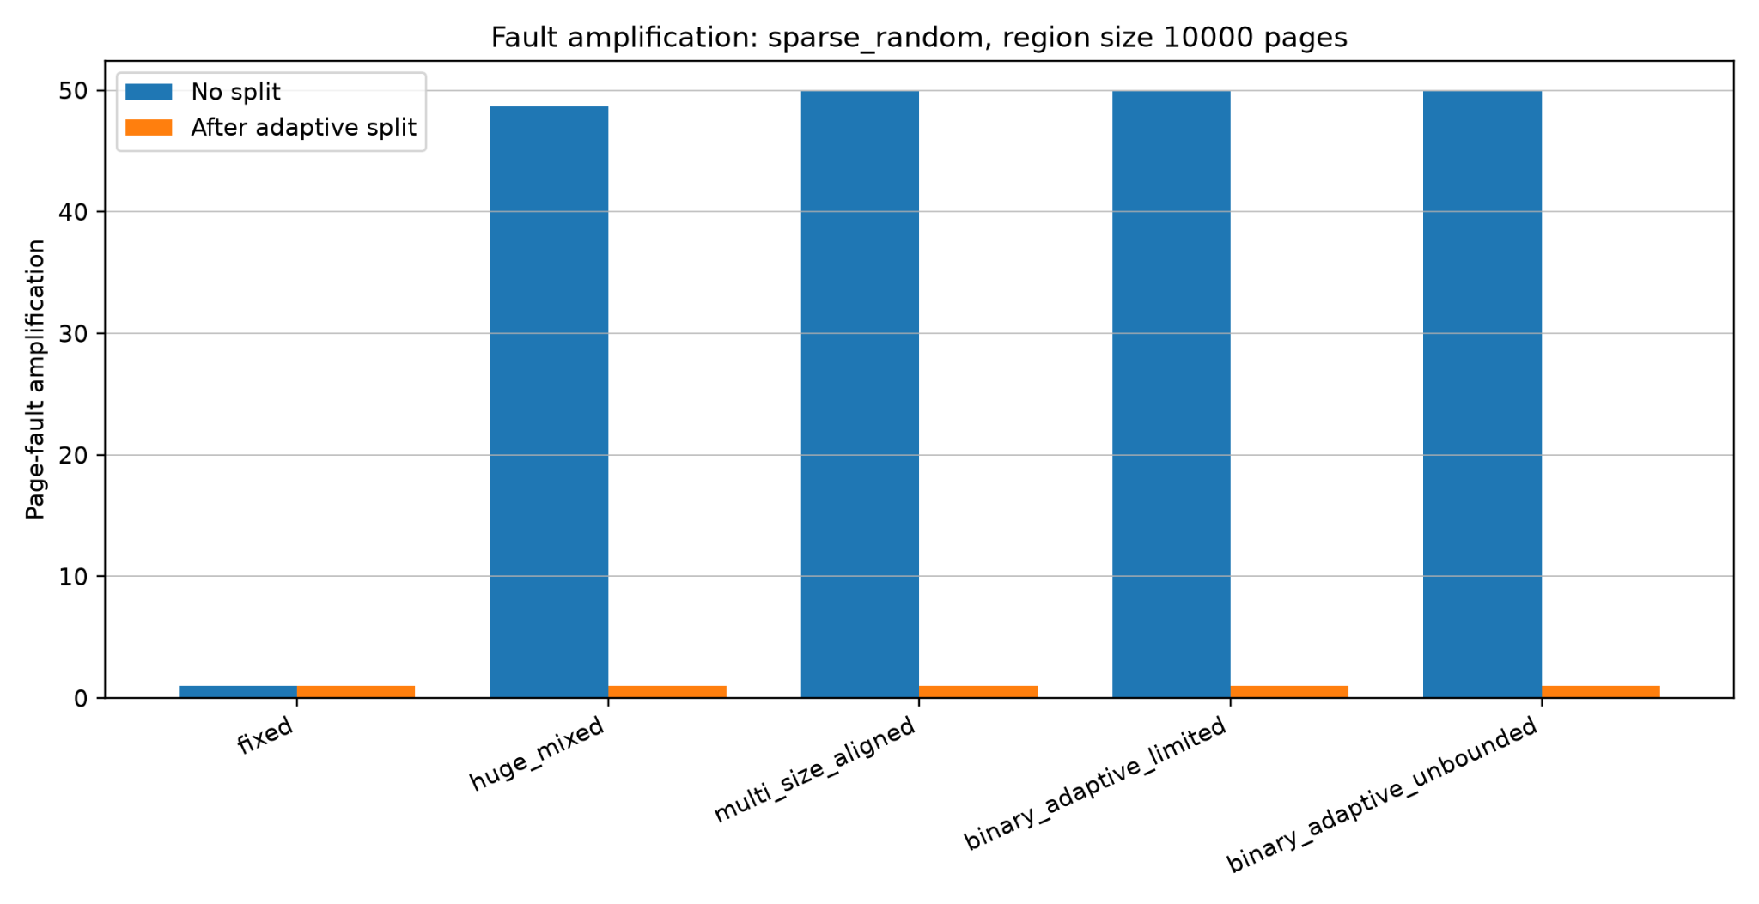
Figure 4. Fault amplification under sparse random access.

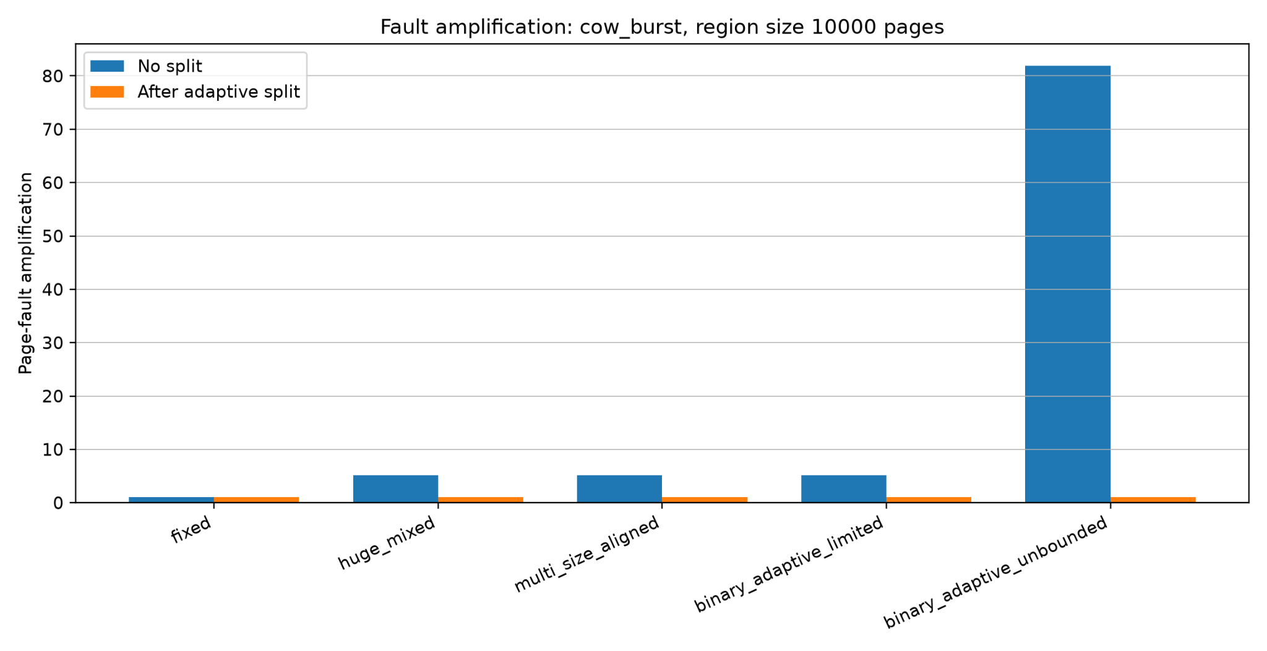
Figure 5. Fault amplification under COW-like burst access.

For the 10,000-page synthetic region, the sparse workload touches 200 distinct pages. The whole-chunk-activation model counts 9,984 pages before splitting for BAP limited, giving a modeled ratio of 49.92; the fixed-page model counts 200 pages (ratio 1.0). For the COW-like burst, the modeled BAP limited ratio is 5.12 and unbounded BAP is 81.92. These observations identify a sensitivity of the chosen activation policy to chunk size. They do not independently establish page-fault behavior or a special BAP advantage over conventional aligned multi-size mappings.
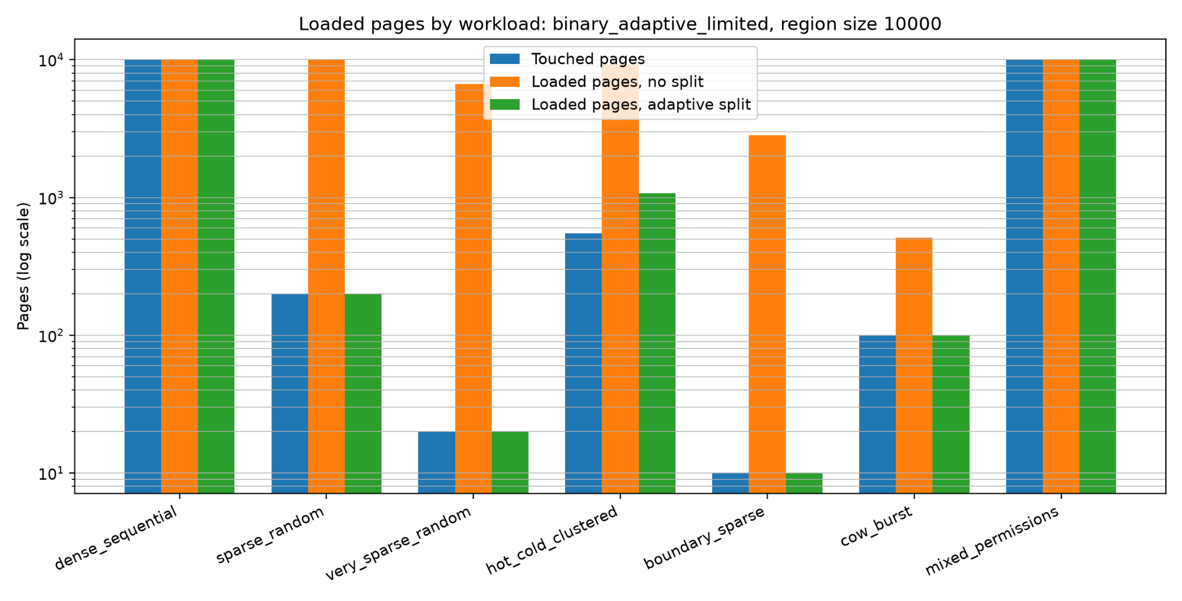
Figure 6. Loaded pages by workload for BAP limited.

7.5 Permission-boundary refinement
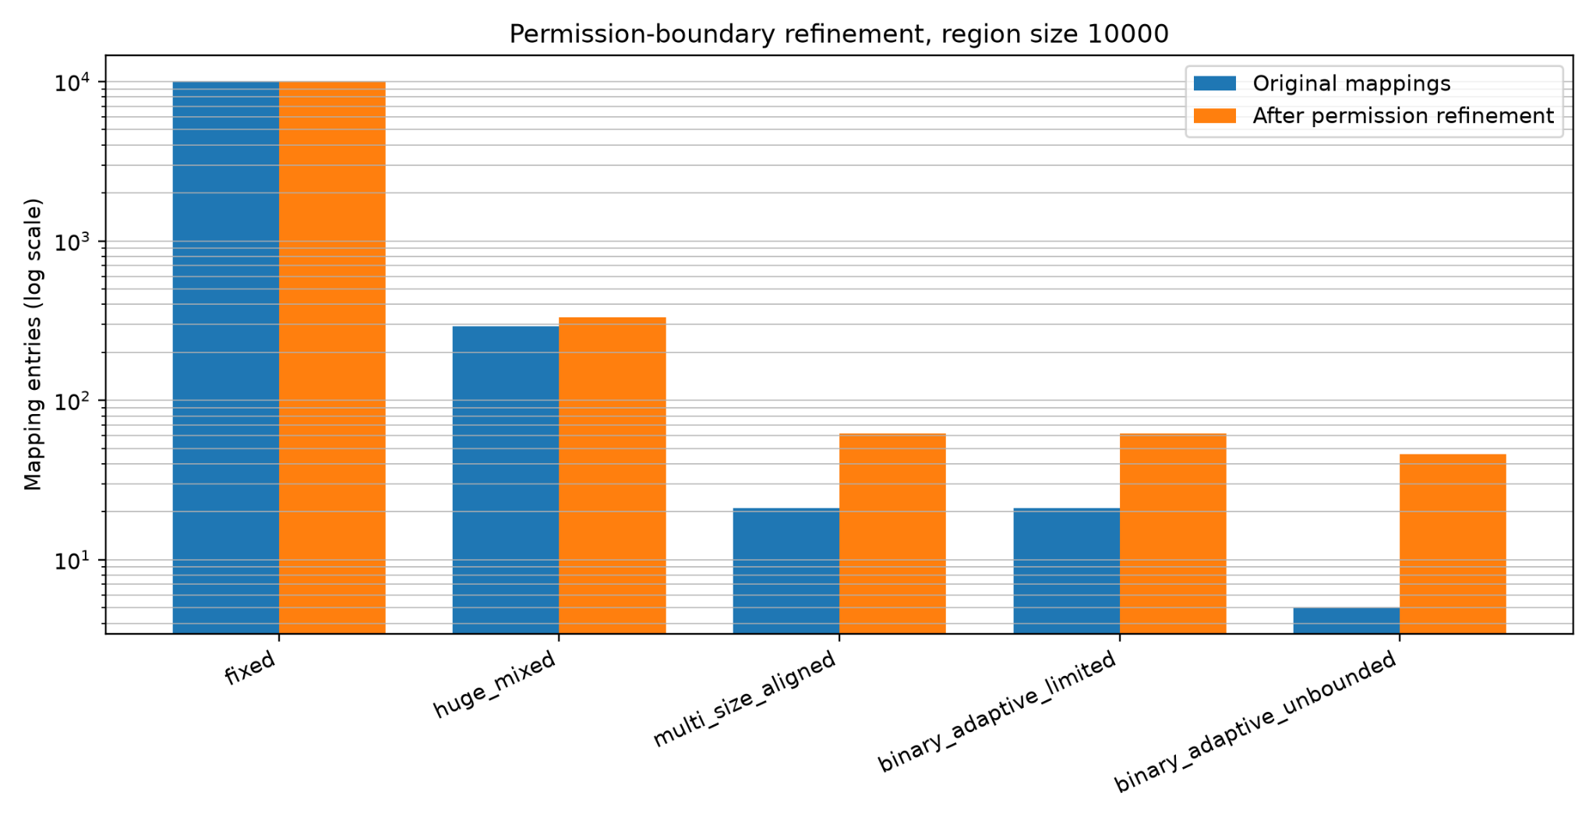
Figure 7. Mapping refinement after synthetic permission boundaries.

Under synthetic permission-boundary refinement, the 10,000-page example increases BAP limited from 21 to 62 logical segments and unbounded BAP from 5 to 46. This models segmentation pressure, not a validated hardware page-table construction; the resulting segments must still satisfy page-size, virtual/physical alignment, and protection requirements for native mappings.

7.6 Sensitivity analysis
Table 9. Mapping-count sensitivity for BAP limited.
Max BAP chunk | Mean mappings
128 | 79
256 | 40
512 | 21
1024 | 12
2048 | 8
Note. Increasing the logical BAP cap reduces chunk count in this sweep; the comparator cap was not co-varied, so cross-strategy trends at different caps are not a controlled native-hardware comparison.

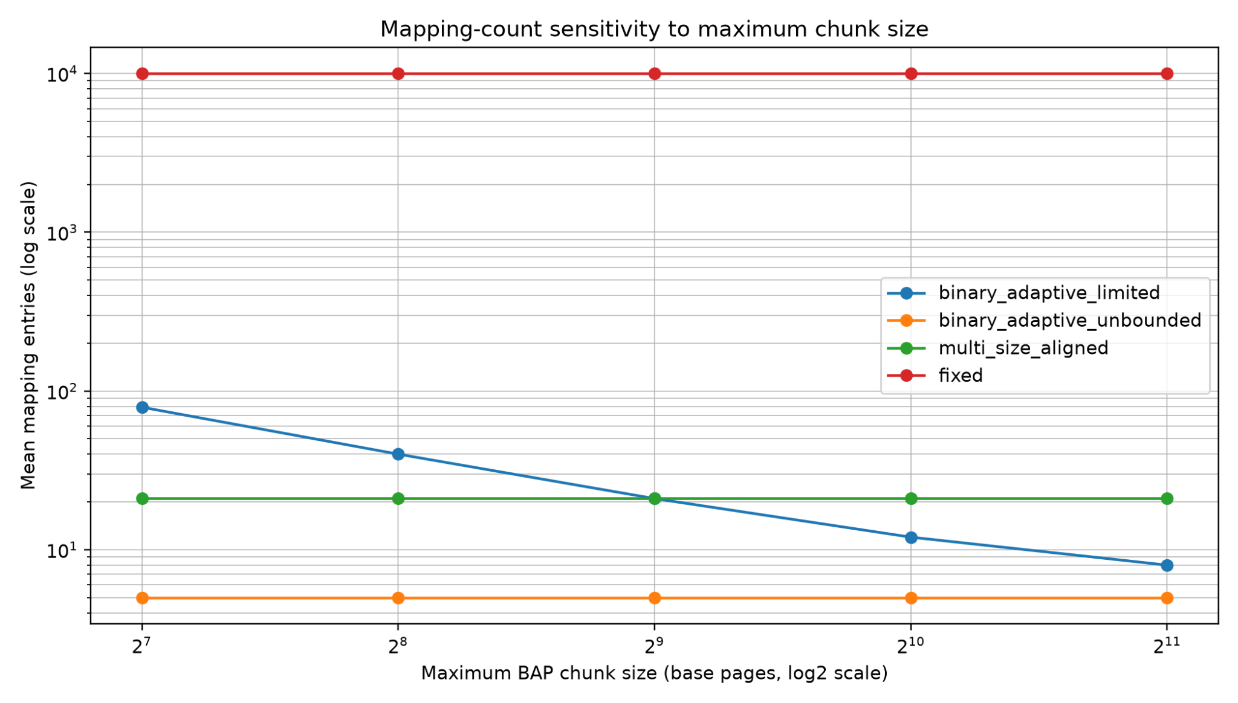
Figure 8. Mapping-count sensitivity to maximum chunk size.

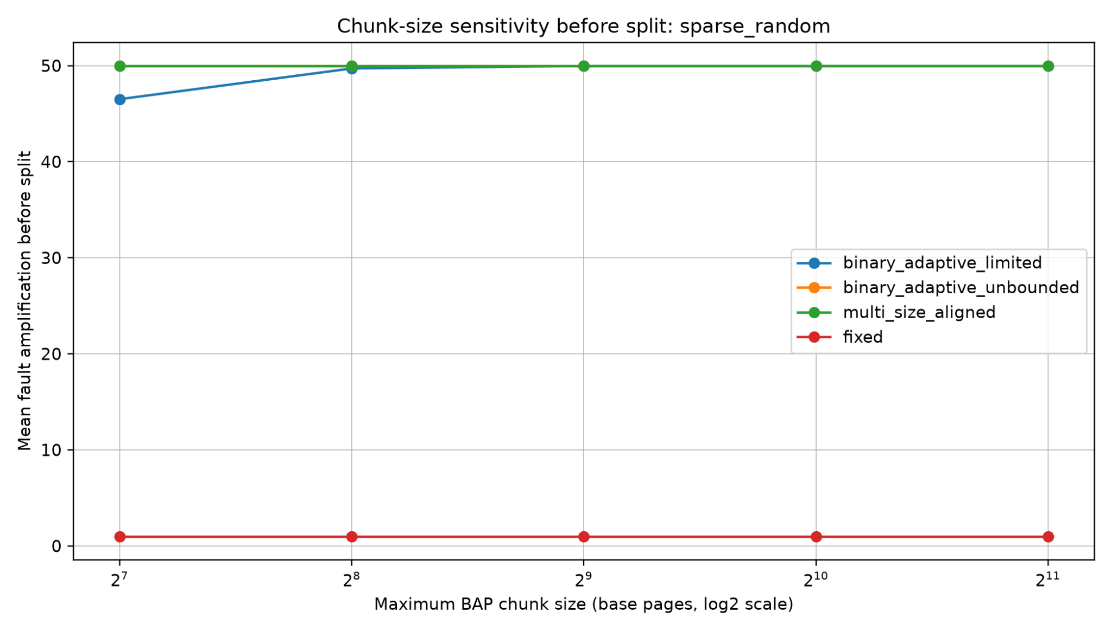
Figure 9. Chunk-size sensitivity before split under sparse random access.

Table 10. Split-threshold tradeoff for BAP limited under hot/cold workload.
Split threshold | Mean amplification after split | Mean added entries
0.05 | 1.95 | 93
0.10 | 1.95 | 93
0.25 | 1.95 | 93
0.50 | 1 | 599.40
Note. Higher split thresholds reduce amplification but can add many mappings.

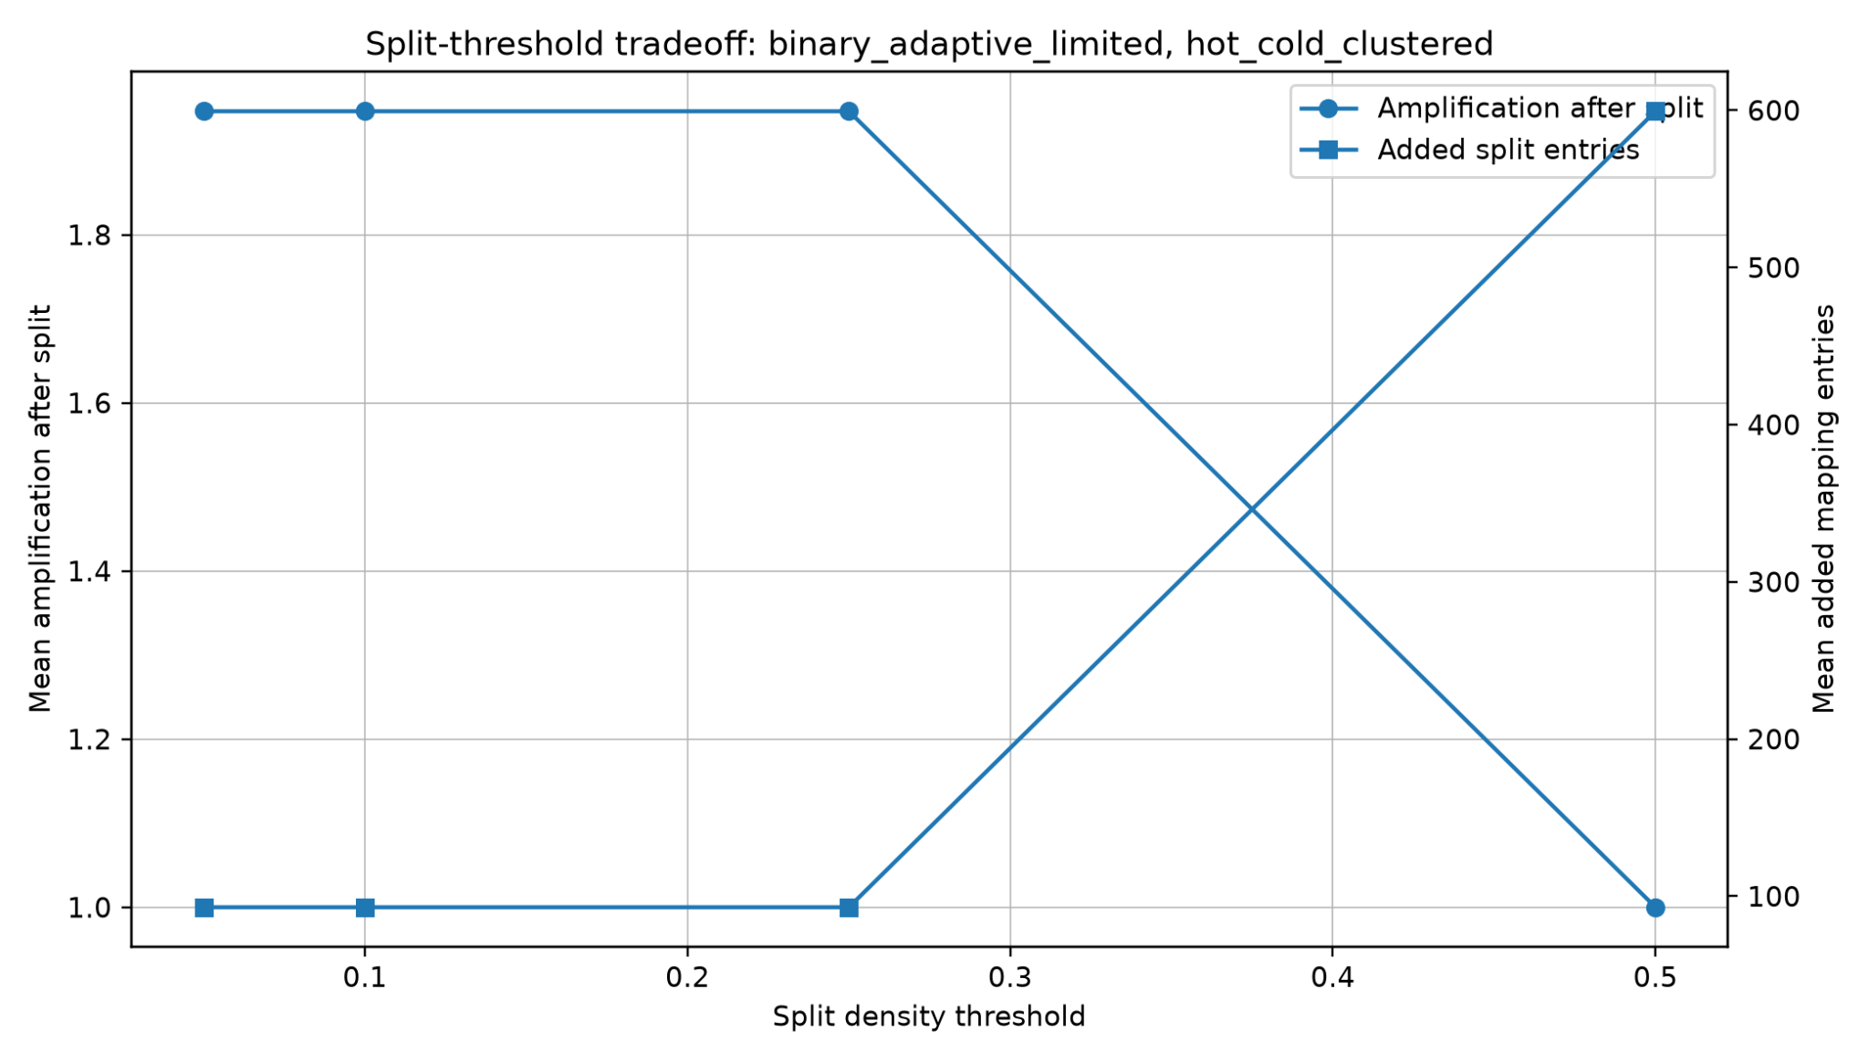
Figure 10. Split-threshold tradeoff for BAP limited.

Sensitivity runs show that increasing the logical BAP cap from 128 to 2,048 pages reduces its chunk count from about 79 to 8 for the 10,000-page region. More aggressive synthetic splitting can reduce the modeled whole-chunk-activation ratio, but at the expense of extra segments. These trends are within-model parameter effects; native leaf-size eligibility, physical backing, and runtime costs were not included. In particular, Figure 8 varies BAP's cap while the comparison baseline's cap is fixed, so it should not be read as a fair hardware mapping advantage.

8. Discussion

8.1 What the results support
- BAP's descending power-of-two region decomposition has a compact mathematical representation and an XOR/MSB rule for locating the containing logical chunk.
- For the aligned starts and shared maximum logical chunk size in v2, BAP limited matches the strong idealized multi-size baseline rather than reducing its logical count.
- Virtual-alignment feasibility is not automatic: v5 shows that region-relative BAP chunks at unaligned starts cannot generally be inserted unchanged as native aligned leaves.
- Unbounded BAP provides a lower bound on *logical* chunk count, but is not an established implementation or TLB-reach upper bound on current hardware.
- Synthetic whole-chunk activation may induce a high loaded/touched ratio in sparse workloads; simplified splitting can reduce this ratio while adding entries.

8.2 What the results do not support
- The reported 21 region-relative BAP chunks at unaligned starts are not 21 legal native translations in either v5 page-size profile; conventional leaf support cannot realize the claimed difference without changes or fallback retiling.
- No experiment demonstrates that BAP reduces real TLB misses, page walks, translation latency, resident memory, or program runtime compared with existing hardware paging.
- The v3 split model does not include optimal legal buddy splitting, runtime split/merge costs, TLB shootdowns, allocator effects, or actual demand-paging/COW behavior.
- The feasibility audit checks necessary virtual eligibility only. It does not certify physical frame continuity, protection correctness, software integration, or novelty relative to other region/range translation designs.

8.3 Design implication
Before attributing practical benefits to BAP, the design must choose an implementation target: (A) a logical metadata/lookup layer on conventional hardware, evaluated through metadata bytes, region search and update overhead without claims about extra native TLB reach; or (B) a new region-relative hardware translation proposal, with explicit descriptors, physical mapping semantics, leaf construction, permission checks, TLB-fill rules and invalidation costs. The next stage should specify one of these paths and compare its total costs with appropriate range-translation and coalescing alternatives.

9. Limitations and Threats to Validity
- No OS or hardware implementation: the reported mapping counts and lookup rule do not establish working virtual-to-physical address translation or actual TLB/page-walk performance.
- Optimistic TLB proxy: summing the largest logical mappings is not a TLB miss-rate simulation and ignores replacement, associativity and native leaf eligibility.
- Virtual vs physical constraints: v5 tests native size and absolute virtual alignment only; no physical contiguity/alignment, fragmentation, NUMA, or compaction is modeled.
- Synthetic activation and splitting: whole-chunk loading is an assumed policy, not a necessary property of conventional page translation; estimated splitting omits implementation cost and legal page-tree structure.
- Synthetic traces and reproducibility: workloads record unique touched pages rather than full address-access sequences; v3 also mixes a randomized Python string hash into its RNG seed, which can affect cross-process reproducibility unless fixed.
- Hardware and novelty: the region-relative lookup cannot be interpreted as a native huge-page mapping without new support or legal retiling. Costs of metadata, region discovery and translation must be compared against prior region/range-based methods.

10. Related Work

10.1 Superpages and huge pages
Superpages and huge pages are the closest practical relatives of BAP. They increase TLB reach by allowing one translation entry to map a larger memory region [1]. Linux HugeTLB provides explicit huge-page support and emphasizes the role of physically contiguous allocation [3]. Transparent Huge Pages attempt to automate huge-page use and include promotion/demotion behavior [2]. BAP differs by decomposing each region into binary chunks and using an XOR/MSB lookup rule instead of relying only on conventional fixed large-page sizes.

10.2 Multi-size page management
Multi-size page management attempts to use several page sizes dynamically. Trident, for example, studies transparent use of 1 GB, 2 MB, and 4 KB pages in Linux [5]. BAP limited is similar in spirit to multi-size management when the maximum chunk size is capped. The difference is that BAP defines the decomposition directly from the binary representation of the region size and uses a region-relative lookup rule.

10.3 Region-based address translation
Direct Segments reduce virtual memory overhead by mapping large contiguous virtual regions directly to contiguous physical memory using base, limit, and offset registers [4]. BAP is less aggressive: it remains page-compatible at the base-page unit and decomposes regions into multiple chunks rather than replacing page mapping with one segment.

10.4 TLB coalescing and contiguity-aware translation
Other work improves address translation by exploiting contiguity in memory mappings, including coalesced TLBs and subregion-contiguity approaches [6]. These approaches are related because they also try to increase the coverage of translation entries. BAP approaches the problem from the virtual-region layout side by using binary decomposition and explicit chunk metadata.

10.5 Buddy allocation
Buddy allocation also uses power-of-two blocks and supports efficient split and merge. BAP is related to the buddy idea, but it applies power-of-two decomposition to virtual memory region mappings and address translation, not only physical memory allocation. The XOR/MSB lookup rule is the specific mechanism that gives BAP its distinct identity.

11. Conclusion
This study introduced BAP as a logical region-relative representation with descending power-of-two decomposition and an XOR/MSB rule that identifies the containing chunk. The existing correctness argument covers logical chunk identification; it does not prove native address-translation feasibility.
Simulators v2–v4 show that BAP limited can greatly reduce *logical* chunk counts versus fixed-size pages and matches idealized multi-size schemes at aligned starts under a shared cap. The apparent benefit at unaligned starts depends on treating relative chunks as translation entries. The v5 virtual-alignment audit makes this dependence explicit: for a 10,000-page region starting at virtual page 1, none of the 21 original BAP limited chunks is a directly eligible native leaf in the tested profiles; aligned retiling produces 30 leaves in a hypothetical all-power-of-two profile and 802 in a 4 KiB/2 MiB profile. The workload and splitting figures remain synthetic, policy-dependent proxies.
Consequently, these results support further investigation of BAP's region representation and lookup method, not a demonstrated TLB speedup or kernel-ready alternative. The next research task is to specify a complete translation interface or restrict the claim to a metadata organization on existing hardware, then measure its incremental costs and benefits against established range-mapping methods.

References
[1] J. Navarro, S. Iyer, P. Druschel, and A. Cox. Practical, Transparent Operating System Support for Superpages. OSDI 2002. https://www.usenix.org/conference/osdi-02/practical-transparent-operating-system-support-superpages
[2] Linux Kernel Documentation. Transparent Hugepage Support. https://docs.kernel.org/admin-guide/mm/transhuge.html
[3] Linux Kernel Documentation. HugeTLB Pages. https://docs.kernel.org/admin-guide/mm/hugetlbpage.html
[4] A. Basu et al. Efficient Virtual Memory for Big Memory Servers. ISCA 2013. https://research.cs.wisc.edu/multifacet/papers/isca13_direct_segment.pdf
[5] V. S. S. Ram, A. Panwar, and A. Basu. Trident: Harnessing Architectural Resources for All Page Sizes in x86 Systems. MICRO 2021. https://www.csa.iisc.ac.in/~arkapravab/papers/MICRO21_Trident.pdf
[6] C. Yu, Y. Bai, and R. Wang. Enabling Large-Reach TLBs for High-Throughput Processors by Exploiting Memory Subregion Contiguity. arXiv:2110.08613, 2021. https://arxiv.org/abs/2110.08613
[7] A. Silberschatz, P. B. Galvin, and G. Gagne. Operating System Concepts. Wiley. Standard textbook reference for paging, segmentation, virtual memory, and memory-management background.
[8] BAP simulation artifacts, project repository: https://github.com/abdojat/binary-adaptive-paging (simulator_v2.py, simulator_v3_workloads.py, sensitivity_v4.py and archived result tables). The v5 feasibility script and summary are a separate supplementary artifact pending repository integration.

Appendix A. Reproducibility Notes
The original v2–v4 results can be regenerated using the commands below. The supplementary v5 structural audit uses Python's standard library only and produces 72 cases in results_v5/feasibility_summary_v5.csv; its code and outputs should be committed with a fixed revision before submission.
python simulator_v2.py --validate --tlb-entries 64
python simulator_v3_workloads.py --validate --tlb-entries 64
python sensitivity_v4.py --simulator-path simulator_v3_workloads.py
python feasibility_v5.py --validate --out results_v5/feasibility_summary_v5.csv

The most important generated files were:
- fair_comparison_start0_v2.csv
- upper_bound_comparison_start0_v2.csv
- alignment_effect_v2.csv
- selected_workload_comparison_v3.csv
- sensitivity_aggregated_v4.csv
- fair_mapping_entries_v2.png
- upper_bound_mapping_entries_v2.png
- fault_amplification_sparse_random_v3.png
- fault_amplification_cow_burst_v3.png
- max_chunk_mapping_count_v4.png
- threshold_split_tradeoff_v4.png
The public repository currently contains the earlier simulator versions and their results. The v5 feasibility script, report, and CSV are supplied separately with this revision and should be added to the public repository before scientific submission. After fixing the v3 Python hash-based seed, rerun and record exact commands, Python/dependency versions, code revision, and output checksums.

